KCET 20

# Question 1

Which one of the products of the following reactions does not react with Hinsberg reagent to form sulphonamide? [25 Jul 2021]

1. 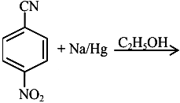
2. 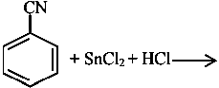
3. 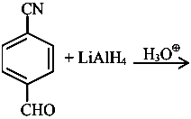
4. 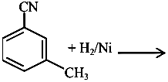

# Question 2

An organic compound "A" on treatment with benzene sulphonyl chloride gives compound $B.B$ is soluble in dil. $NaOH$ solution. Compound $A$ is______________.

$C_{6}H_{5}−N−{\left({CH}_{3}\right)}_{2}$

$C_{6}H_{5}−{NHCH}_{2}{CH}_{3}$

$C_{6}H_{5}−{CH}_{2}{NHCH}_{3}$

$C_{6}H_{5}−CH−{NH}_{2}$

# Question 3

The total number of reagents from those given below, that can convert nitrobenzene into aniline is _______________ (Integer answer)

|  |  |  |
| --- | --- | --- |
|  |  |  |
|  | Raney nickel |  |

# Question 4

Match List I with List II.

| List-I | List-II |  |  |  |
| --- | --- | --- | --- | --- |
| A. Benzenesulphonyl Chloride | I. Test for primary amines |  |  |  |
| B. Hoffmann bromamide reaction | II. Anti Saytzeff |  |  |  |
| C. Carbylamine reaction | III. Hinsberg reagent |  |  |  |
| D. Hoffmann orientation | IV. Known reaction of Isocyanates |  |  |  |

Choose the correct answer from the options given below:

1. A-IV, B-III, C-II, D-I
2. A-IV, B-II, C-I, D-II
3. A-III, B-IV, C-I, D-II
4. A-IV, B-III, C-I, D-II

# Question 5

Consider the following sequence of reaction :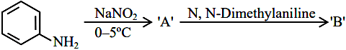product ’ ’ is :

1. image
2. 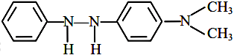
3. 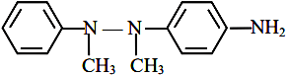
4. image

# Question 6

Given below are two statements :Statement I : In Hofmann degradation reaction, the migration of only an alkyl group takes place from carbonyl carbon of the amide to the nitrogen atom.Statement II : The group is migrated in Hofmann degradation reaction to electron deficient atom.In the light of the above statements, choose the most appropriate answer from the options given below:

1. Both Statement I and Statement II are correct.
2. Both Statement I and Statement II are incorrect.
3. Statement I is correct but Statement II is incorrect.
4. Statement I is incorrect but Statement II is correct.

# Question 7

During halogen test, sodium fusion extract is boiled with concentrated ${HNO}_{3}$ to

1. remove unreacted sodium
2. decompose cyanide or sulphide of sodium
3. extract halogen from organic compound
4. maintain the $pH$ of extract.

# Question 8

The decreasing order of basicity of the following amines is: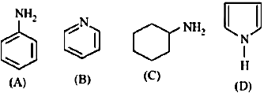

$\left(A\right)>\left(C\right)>\left(D\right)>\left(B\right)$

$\left(C\right)>\left(A\right)>\left(B\right)>\left(D\right)$

$\left(B\right)>\left(C\right)>\left(D\right)>\left(A\right)$

$\left(C\right)>\left(B\right)>\left(A\right)>\left(D\right)$

# Question 9

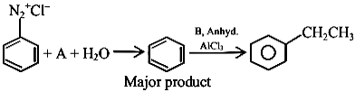the chemical reactions given above $A$ and $B$ respectively are:

1. $H_{3}{PO}_{2}$ and ${CH}_{3}{CH}_{2}Cl$
2. ${CH}_{3}{CH}_{2}OH$ and $H_{3}{PO}_{2}$
3. $H_{3}O_{2}$ and ${CH}_{3}{CH}_{2}OH$
4. ${CH}_{3}{CH}_{2}Cl$ and $H_{3}{PO}_{2}$

# Question 10

The products A and B formed in the following reaction scheme are respectively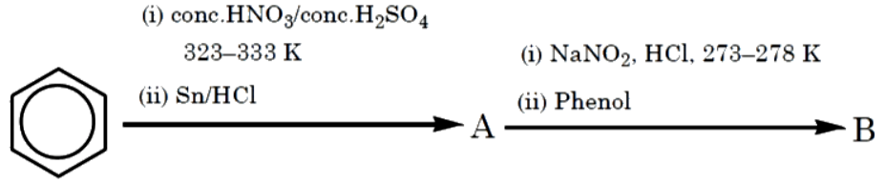

1. 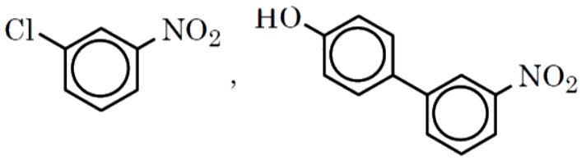
2. 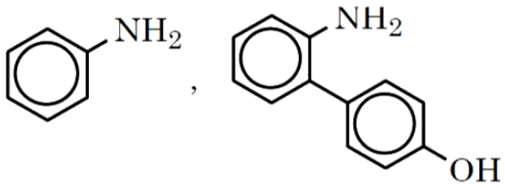
3. 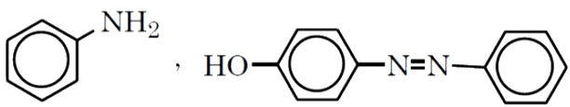
4. 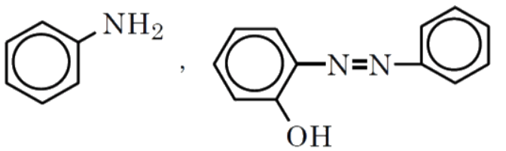

# Question 11

Which of the following is not a correct statement for primary aliphatic amines?

1. The intermolecular association in primary amines is less than the intermolecular association in secondary amines.
2. Primary amines on treating with nitrous acid solution form corresponding alcohols except methyl amine.
3. Primary amines are less basic than the secondary amines.
4. Primary amines can be prepared by the gabriel phthalimide synthesis.

# Question 12

The total number of reagents from those given below, that can convert nitrobenzene into aniline is _______________ (Integer answer)

|  |  |  |
| --- | --- | --- |
|  |  |  |
|  | Raney nickel |  |

# Question 13

Match List I with List II.

| List-I | List-II |  |  |  |
| --- | --- | --- | --- | --- |
| A. Benzenesulphonyl Chloride | I. Test for primary amines |  |  |  |
| B. Hoffmann bromamide reaction | II. Anti Saytzeff |  |  |  |
| C. Carbylamine reaction | III. Hinsberg reagent |  |  |  |
| D. Hoffmann orientation | IV. Known reaction of Isocyanates |  |  |  |

Choose the correct answer from the options given below:

1. A-IV, B-III, C-II, D-I
2. A-IV, B-II, C-I, D-II
3. A-III, B-IV, C-I, D-II
4. A-IV, B-III, C-I, D-II

# Question 14

Which of the following is not a correct statement for primary aliphatic amines?

1. The intermolecular association in primary amines is less than the intermolecular association in secondary amines.
2. Primary amines on treating with nitrous acid solution form corresponding alcohols except methyl amine.
3. Primary amines are less basic than the secondary amines.
4. Primary amines can be prepared by the gabriel phthalimide synthesis.

# Question 15

The total number of electrons around the nitrogen atom in amines are,

# Question 16

What is the correct name for a molecule that has two amino groups in opposing (para) locations around a benzene ring?

1. Benzenediamine
2. Benzene-1,4-diamine
3. p-Aminoaniline
4. 4-Aminobenzenamine

# Question 17

An organic compound "A" on treatment with benzene sulphonyl chloride gives compound $B.B$ is soluble in dil. $NaOH$ solution. Compound $A$ is______________.

$C_{6}H_{5}−N−{\left({CH}_{3}\right)}_{2}$

$C_{6}H_{5}−{NHCH}_{2}{CH}_{3}$

$C_{6}H_{5}−{CH}_{2}{NHCH}_{3}$

$C_{6}H_{5}−CH−{NH}_{2}$

# Question 18

The total number of reagents from those given below, that can convert nitrobenzene into aniline is _______________ (Integer answer)

|  |  |  |
| --- | --- | --- |
|  |  |  |
|  | Raney nickel |  |

# Question 19

A primary aliphatic amine on reaction with nitrous acid in cold ( $273 K)$ and there after raising temperature of reaction mixture to room temperature (298 K), gives.

1. nitrile
2. alcohol
3. diazonium salt
4. secondary amine

# Question 20

Match List I with List II.

| List-I | List-II |  |  |  |
| --- | --- | --- | --- | --- |
| A. Benzenesulphonyl Chloride | I. Test for primary amines |  |  |  |
| B. Hoffmann bromamide reaction | II. Anti Saytzeff |  |  |  |
| C. Carbylamine reaction | III. Hinsberg reagent |  |  |  |
| D. Hoffmann orientation | IV. Known reaction of Isocyanates |  |  |  |

Choose the correct answer from the options given below:

1. A-IV, B-III, C-II, D-I
2. A-IV, B-II, C-I, D-II
3. A-III, B-IV, C-I, D-II
4. A-IV, B-III, C-I, D-II

# Question 21

The major product formed in the following reaction is.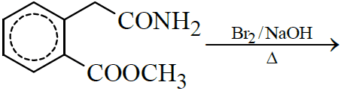

1. 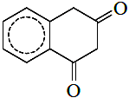
2. 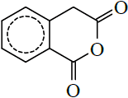
3. 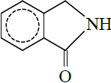
4. 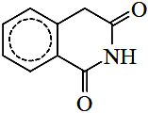

# Question 22

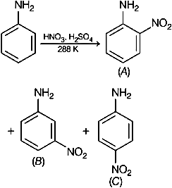the given reaction, percentage yield of,

$\left(C\right)>\left(A\right)>\left(B\right)$

$\left(B\right)>\left(C\right)>\left(A\right)$

$\left(A\right)>\left(C\right)>\left(B\right)$

$\left(C\right)>\left(B\right)>\left(A\right)$

# Question 23

Given below are two statements :Statement I: Aniline reacts with con. $H_{2}{SO}_{4}$ followed by heating at $453−473 K$ gives p-aminobenzene sulphonic acid, which gives blood red colour in the ’Lassaigne’s test’.II: In Friedel - Craft’s alkylation and acylation reactions, aniline forms salt with the ${AlCl}_{3}$ catalyst.to this, nitrogen of aniline aquires a positive charge and acts as deactivating group.the light of the above statements, choose the correct answer from the options given below :

1. Statement I is false but statement II is true
2. Both statement I and statement II are false
3. Statement I is true but statement II is false
4. Both statement I and statement II are true